Software Requirements Specification

for

Art Attack: a visual art gallery

Version 1.0 approved

Prepared by Sabina (22k-5198), Laiba (22k-5195), Mustafa (22k-4818)

30 Nov 2023

Table of Contents

Table of Contents ….....................................................................................................................ii

1. Introduction …........................................................................................................................1

1.1 Purpose …........................................................................................................................................1

1.2 Document Conventions …...............................................................................................................1

1.3 Intended Audience and Reading Suggestions ….............................................................................1

1.4 Product Scope …............................................................................................................................ 2

1.5 References …...................................................................................................................................2

2. Overall Description …............................................................................................................2

2.1 Product Perspective ….................................................................................................................... 2

2.2 Product Functions …...................................................................................................................... 2

2.3 User Classes and Characteristic …................................................................................................. 3

2.4 Operating Environment ….............................................................................................................. 3

2.5 Design and Implementation Constraints ….................................................................................... 3

2.6 User Documentation ….................................................................................................................. 3

2.7 Assumptions and Dependencies…...................................................................................................3

3. External Interface Requirements ….................................................................................... 4

3.1 User Interfaces …........................................................................................................................... 4

3.2 Hardware Interfaces …................................................................................................................... 4

3.3 Software Interfaces ….................................................................................................................... 4

3.4 Communications Interfaces …........................................................................................................ 4

4. System Features ….................................................................................................................4

4.1 Artist Profile Management….......................................................................................................... 4

4.2 Artwork Showcase…...................................................................................................................... 5

4.3 Online Auctions …..........................................................................................................................6

4.4 Search and Filtering ....................................................................................................................... 7

4.5 Event Management…..................................................................................................................... 8

5. Other Nonfunctional Requirements …................................................................................ 9

5.1 Performance Requirements …........................................................................................................ 9

5.2 Safety Requirements ….................................................................................................................. 9

5.3 Security Requirements …............................................................................................................... 9

5.4 Software Quality Attributes …....................................................................................................... 9

5.5 Business Rules …............................................................................................................................9

Appendix A: Glossary …...........................................................................................................10

Appendix B: Analysis Models ….............................................................................................. 10

Appendix C: To Be Determined List …................................................................................... 10

Appendix D: Images from the Working Project …................................................................ 10

# Introduction

## Purpose

The purpose of "Art Attack” is to create a visually appealing and sophisticated website that will serve as an online platform to display artworks from various artists, a platform where the artists will be able to interact with one another. Artists can also build up their audience and following, promote art-related events, and provide an interactive experience for art enthusiasts and potential buyers. Art enthusiasts can favourite upcoming art events. It is also an e-commerce website where potential buyers can participate in auctions to collect rare art pieces of their favourite artists.

## Document Conventions

* Main Heading   
  Font: Times  
  Size: 18  
  Style: none
* Subheading  
  Font: Times  
  Size: 14  
  Style: Bold
* Body  
  Font: Calibri  
  Size: 12  
  Style: none

## Intended Audience and Reading Suggestions

This Software requirement specification document is intended to be read by project managers, developers, marketing staff, testers, users, and documentation writers. The document is organized to be read by beginning with an overview, followed by sections pertinent to each type of reader

The software is intended to be used by:

* Artists looking to display and sell their artwork.
* Event Organizers.
* Art collectors searching for unique pieces.
* General public and art enthusiasts interested in appreciating and exploring art.

## Product Scope

"Art Attack" is a virtual art gallery that aims to provide a platform for artists to display and sell their artworks. The website targets artists, art collectors, and art enthusiasts. It aspires to become a leading platform for art-related content, events, and user interaction.

The art gallery website will include following features:

* Artist profiles and their portfolios
* Online gallery for exhibitions
* Event listing for art auctions
* Blogs and news for art related content
* Searchable and categorized display for art

## References

* IEEE STD 830-1998, IEEE recommended practice for software requirement specification.
* <https://artsandculture.google.com/>
* <https://www.artciti.com/>
* <https://cliftonartgallery.com/>

# Overall Description

## Product Perspective

"Art Attack" is a standalone virtual art gallery platform. It is not part of a larger system or any other pre-existing system. It aims to replace traditional/physical art exhibition spaces and enhance the online presence of artists.

## Product Functions

* Display artworks and artist online portfolios
* Enable secure buying and selling of artwork
* List and promote art-related events
* Publish art-related content
* User management, marketing, and customer support

## User Classes and Characteristics

* Artists: Manage profiles, portfolios, and artworks
* Art Enthusiasts: Browse, interact with artists
* Art Collectors: Browse and purchase artworks
* Event Organizers: Manage art-related events
* Administrators: Oversee platform operations
* Marketing Team: Promote the platform and analyze user engagement
* Customer Support Team: Assist users with technical issues
* Web Developers: Design, develop, and maintain the website
* Payment Gateway: Handle secure payment processing
* Content Writers: Create content for the website

## Operating Environment

The software will work in a web-based environment. It is compatible with standard web browsers and requires a reliable internet connection. It will work on all devices with an internet connection and an internet browser.

## Design and Implementation Constraints

* Use of Figma, HTML, CSS, JavaScript for front-end
* Node.js for back-end development
* Integration with secure payment processing systems

## User Documentation

User documentation will include SRS Document, a product: front end, and PowerPoint presentation for ease in understanding the system

## Assumptions and Dependencies

* The mentioned system will use the latest tool available on the market, so it is assumed the user will use the latest web browser to load the UI properly.
* There is involvement of JavaScript code so it is assumed that the user will not disable the JavaScript in the browser to run the website smoothly.
* Users of the system are technically skilled, and they understand how to handle this system.
* Artists will provide accurate and complete information.
* Secure payment processing services are available.
* The details of the art gallery are all correct.
* The website will be available 24hrs a day.
* The seller and buyer are genuine and valid.

# External Interface Requirements

## User Interfaces

There are two types of user interface.

* Artist profile
* Art Enthusiast profile

In artist profile, the user is given options to upload artworks, sell artworks, hold auctions

In art enthusiast profile, the user is given options to favorite art pieces, buy art pieces

## Hardware Interfaces

"Art Attack” is a website so all the hardware interfaces will be of the server on which it will be running. Hence the website will incorporate the server for all the hardware instances such as CPU, memory and communication.

## Software Interfaces

* Integration with secure payment processing systems
* Compatibility with databases, operating systems, and web technologies

## Communications Interfaces

Connections to the system will be over TCP/IP connection.

The interface allows easy navigation between different program features and options.

The system can handle multiple requests simultaneously without causing delay.

# System Features

The following are the features/ functional requirements of Art Attack

### 4.1 Artist Profile Management

4.1.1 Description and Priority

Artist Profile Management is an important functionality for artists to create and manage profiles, including personal information and portfolio details. This functionality influences user engagement, connecting artists with audiences and potential buyers.

**Priority: High**

The priority is set as High due to its benefit in attracting artists and buyers, the risk of decreased engagement if poorly implemented, moderate development cost, and low risk due to straightforward functionality.

4.1.2 Stimulus/Response Sequences

* **Stimulus:** Artist logs in and accesses profile management.

**Response:** The system validates the artist's credentials and grants access to profile editing functionalities.

* **Stimulus:** Artist updates profile information or adds portfolio details.

**Response:** The system processes and saves the provided information, updating the artist's profile accordingly.

4.1.3 Functional Requirements

* **REQ-1:** Artists can upload profile pictures.

Description: Artists must be able to upload images representing themselves or their artworks.

Response to Errors: If the uploaded file format is incompatible, the system will prompt the user to upload a valid image (e.g., JPG, PNG) and provide clear instructions on accepted file types and sizes.

* **REQ-2:** Artists provide a biography and contact information.

Description: Artists should be able to add a biography and contact details for audience engagement.

Response to Errors: The system will ensure mandatory fields (e.g., email, bio) are filled and will prompt the user to complete missing information if attempting to save incomplete data.

## 4.2 Artwork Showcase

4.2.1 Description and Priority

The system’s Artwork Showcase feature provides users with a visually engaging experience to explore and purchase artworks.

**Priority: High**

Its significance lies in attracting users, driving sales, and the risk of reduced engagement if artworks aren't adequately showcased. Development costs are moderate, and the functionality is straightforward, carrying low risk.

4.2.2 Stimulus/Response Sequences

* **Stimulus:** Users browse artworks, select items, and proceed to checkout.

**Response:** The system updates inventory in real-time and facilitates seamless transaction processing.

4.2.3 Functional Requirements

* **REQ-3:** Artworks display with images, titles, and descriptions.

Description: Ensures artworks are showcased with high-resolution images, descriptive titles, and informative descriptions.

Error Handling: If images or descriptions fail to load, the system should display placeholders or informative messages to indicate the issue to users.

* **REQ-4:** Users can add artwork to a shopping cart.

Description: Enable users to add desired artworks to a shopping cart for convenient purchase.

Error Handling: If adding an artwork fails (e.g., due to technical issues), the system should alert users and provide alternative steps or retry options.

## 4.3 Online Auctions or Biding

4.3.1 Description and Priority

The Online Auctions or Bidding feature enables users to participate in auctions or bidding processes for selecting artworks showcased on the platform.

**Priority: Medium**

This feature provides an interactive way for users to acquire exclusive artworks through auctions or bidding, enhancing potential sales. However, it carries a moderate priority due to its specialized nature and potentially lower frequency of use compared to core functionalities.

4.3.2 Stimulus/Response Sequences

* **Stimulus:** Users view an artwork available for auction or bidding.

**Response:** The system displays bidding options, current bids, and bidding deadlines.

* **Stimulus:** Users place bids on the artwork.

**Response:** The system displays bidding options, current bids, and bidding deadlines.

4.3.3 Functional Requirements

* **REQ-5:** Bidding Interface for Artworks

Description: Provide an intuitive interface displaying auction details, current bids, bid increments, and countdown timer.

Error Handling: In case of technical errors during bidding, the system should maintain a bid history and allow users to re-attempt bidding without losing previous bids.

## 4.4 Search and Filtering

4.4.1 Description and Priority

The Search and Filtering feature empowers users to easily discover artworks based on specific criteria, enhancing their browsing experience on the platform.

**Priority: High**

Its high priority is attributed to its fundamental role in user engagement and facilitating ease of access to desired artworks.

4.4.2 Stimulus/Response Sequences

* **Stimulus:** Users input search queries or select filters (e.g., artist name, art style).

**Response:** The system displays filtered results matching the user's criteria, allowing exploration.

4.4.3 Functional Requirements

* **REQ-6:** Search Functionality

Description: Implement a search bar allowing users to input keywords, artist names, or artwork genre for instant search results.

Error Handling: Notify users if searches yield no results and suggest alternative search terms.

* **REQ-7:** Filtering Options

Description: Provide filter options based on various parameters such as artist, art style, medium, size, price range, etc.

Error Handling: Ensure selected filters generate relevant results, avoiding mismatches in displayed artworks.

## 4.5 Event Management

4.5.1 Description and Priority

The Event Management feature enables the listing and organization of art-related events such as exhibitions, workshops, or art talks on the platform.

**Priority: Medium**

This feature facilitates user engagement by providing information about various art-related events, its priority is moderate due to its supplementary role compared to core functionalities.

4.5.2 Stimulus/Response Sequences

* **Stimulus:** Admin or users create event details.

**Response:** The system displays event information, including date, time, location, and event descriptions.

* **Stimulus:** Users browse and select events to view details or register.

**Response:** The system allows users to register for events or provides additional information upon selection.

4.5.3 Functional Requirements

* **REQ-8:** Event Listing and Details
* Description: Provide a user-friendly interface to list upcoming events with comprehensive details.

Error Handling: Ensure accurate and updated event information, notify users of any changes or cancellations.

* **REQ-9:** User registrations for Events

Description: Enable users to register for events directly through the platform

Error Handling: Confirm successful event registration and notify users of any registration errors.

# Other Nonfunctional Requirements

## Performance Requirements

1. Loading Time: The system should load artwork images within 3 seconds.

2. Average load time of the start page of website should be less than 5 seconds.

3. Response Time: Average response time of the system should be less than 10 seconds.

## Safety Requirements

To prevent accidental transactions and ensure user confirmation, users must actively confirm purchases, minimizing the risk of unintended financial transactions.

## Security Requirements

* **User Authentication:** User access to accounts requires authentication to enhance security and protect user data.
* **Encryption for Transactions:** Secure encryption protocols must be implemented for payment transactions, safeguarding sensitive financial information.
* **Access Control:** Users should only access their own personal information, enforcing strict access controls to protect user privacy.

## Software Quality Attributes

* **Usability:** The interface design should prioritize user-friendliness, ensuring an intuitive and easily navigable experience for all users.
* **Reliability:** The system must maintain an availability rate of 99%, guaranteeing consistent access for users.

## Business Rules

* **Artist Registration:** Only registered artists are allowed to showcase artworks on the platform, ensuring quality and authenticity.
* **Artwork Duplication:** Artworks cannot be duplicated within the platform, preserving the uniqueness and integrity of the art collection.

Appendix A: Glossary

REQ: Requirements

UML: Unified Modelling Language are diagrams to explain the flow of processes

Actor: It represents a role, external entity that interacts with our system.

Use case: Graphical Represent of interaction among system and actor. It represents the use of the services and functionality by the system by the actor.

Scenario: The time of actual input and expected output.

Activity diagram: Graphical representation of the process flow of use case etc.

WBS: Work Breakdown Structure (WBS) is a hierarchical decomposition of the total scope of work to be carried out by the project team

JavaScript: Scripting Language

HTML: Hypertext Markup Language

CSS: Cascading Style Sheets language used for describing the presentation of a HTML document

Figma: A collaborative interface design tool used for creating, prototyping, and sharing designs.

Node.js: A JavaScript runtime environment used for server-side applications.

TCP/IP: (Transmission Control Protocol/Internet Protocol) The set of rules governing how data is transmitted across networks and the internet.

Web-based Environment: A system or software that operates within internet browsers and requires an internet connection.

Front-end: Front-end refers to the user interface of a website.

Back-end: Back-end refers to the server, application, and database that work behind the scenes to deliver the front-end content.

Appendix B: Analysis Models

Use Case Diagram:

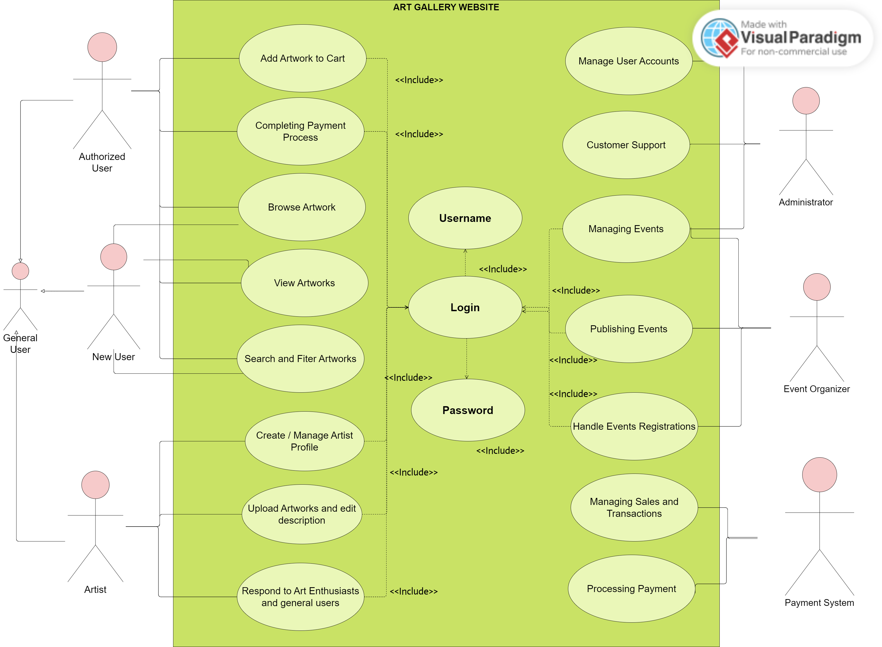

Entity Relation diagram:

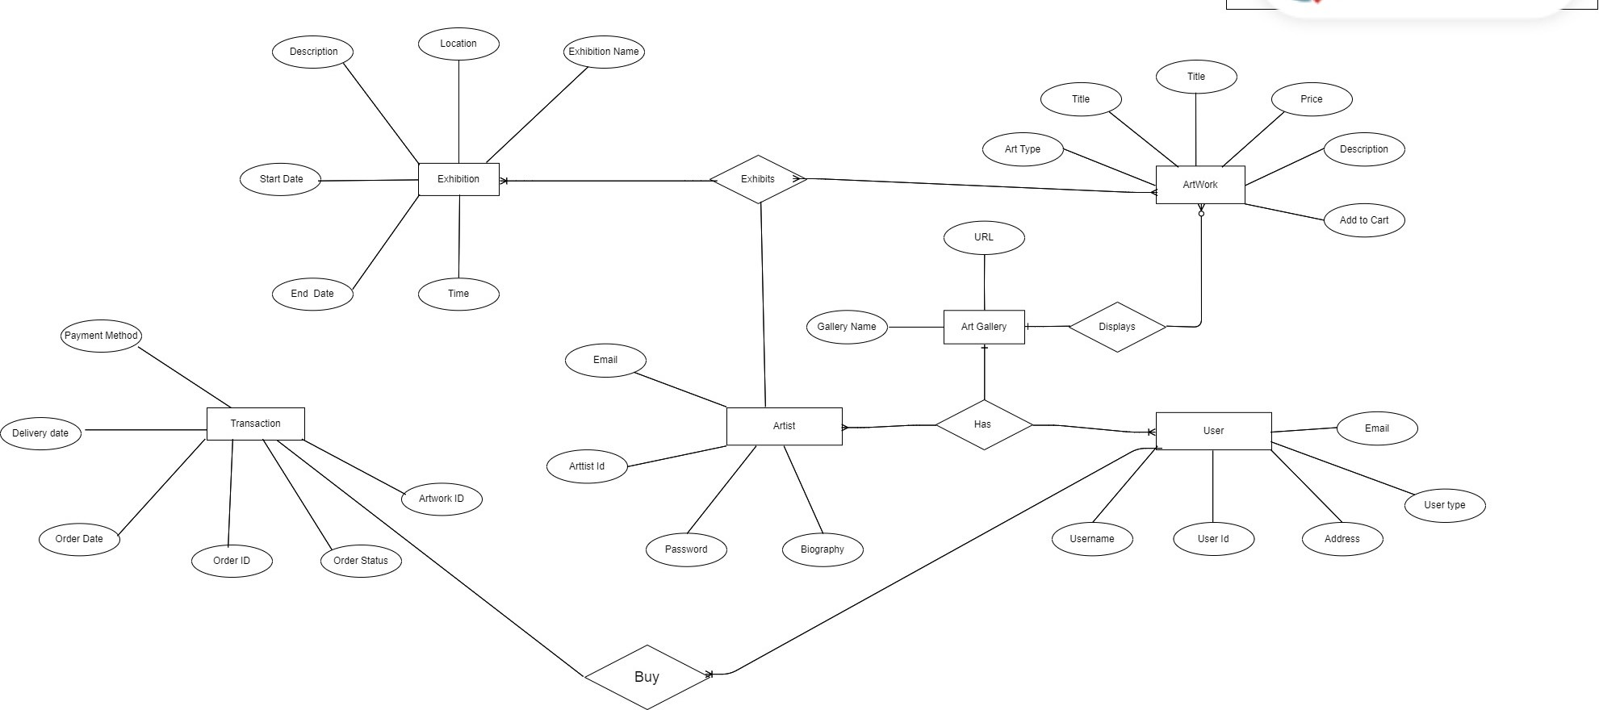

Activity diagram for user

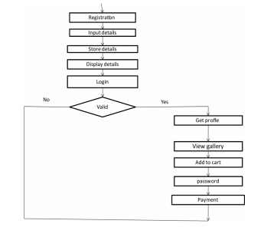

Activity diagram for artist

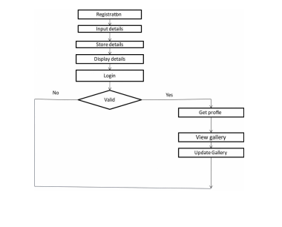

Class Diagram:

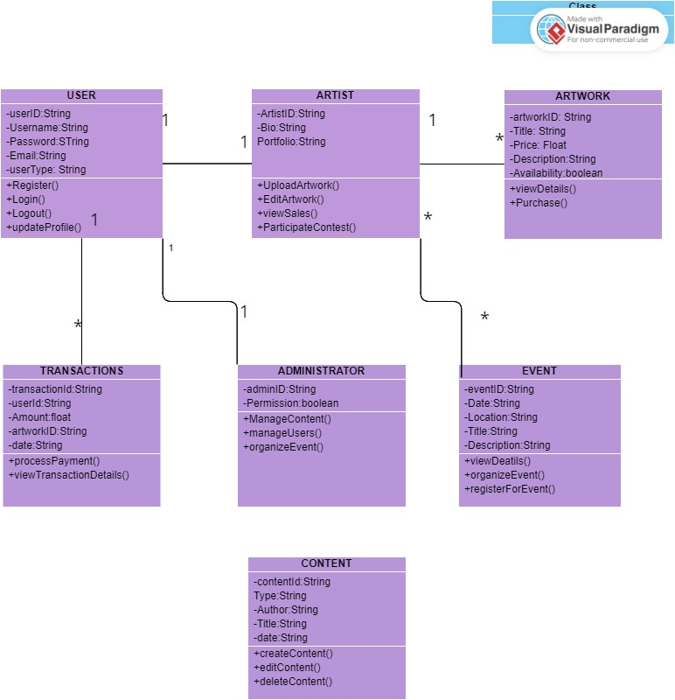

DATA FLOW DIAGRAMS:

User and Artist Interactions:

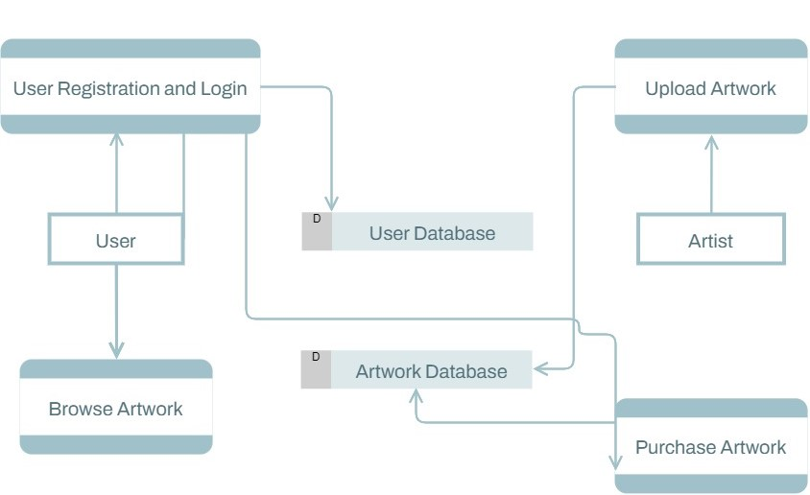

Administrative Functions:

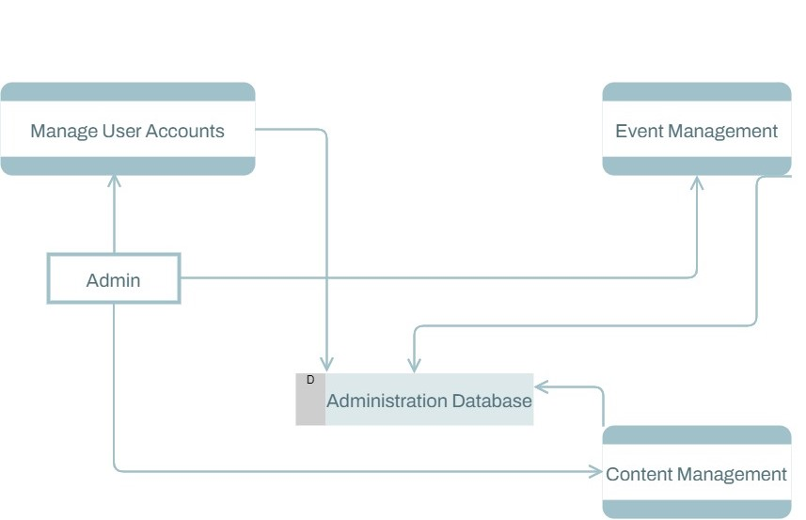

Payment and Transactions:

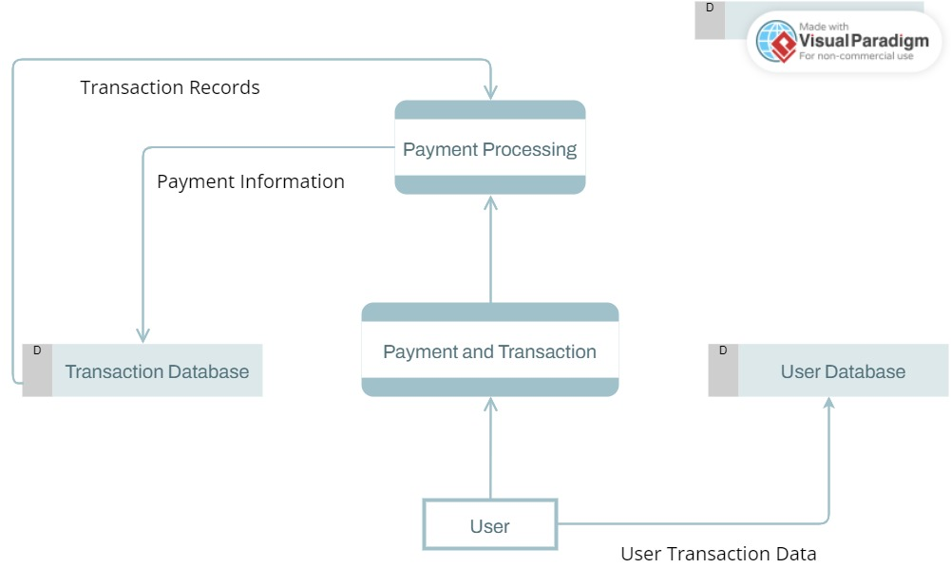

WBS for overall Website:

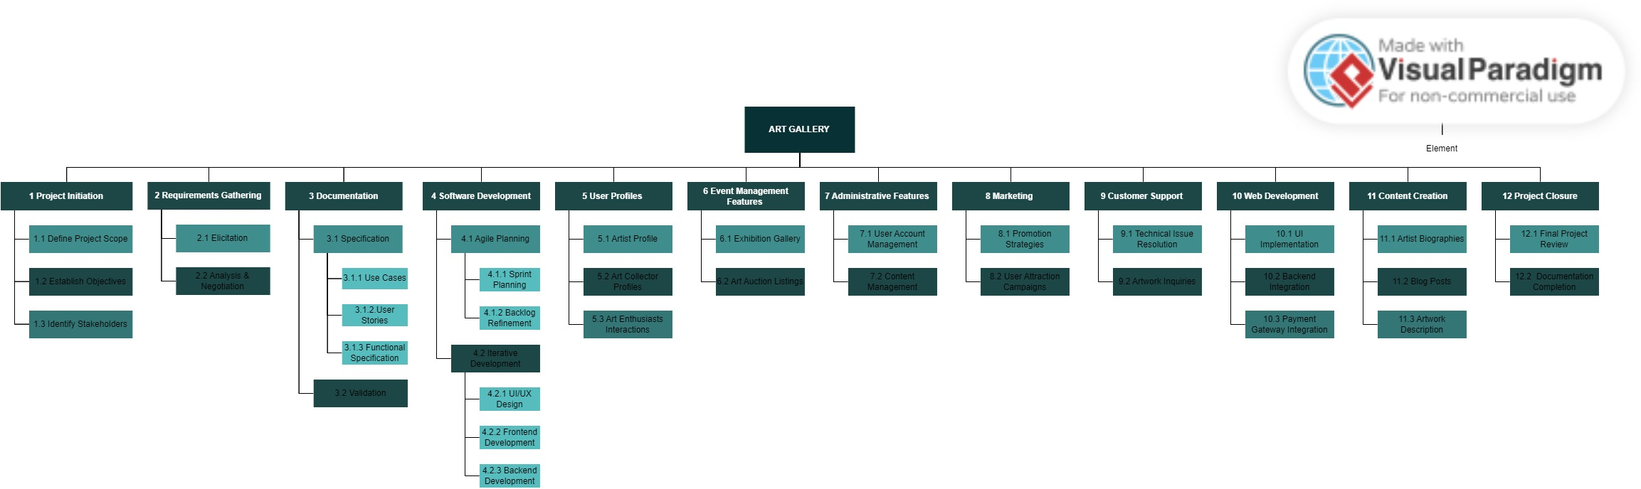

Appendix C: To Be Determined List

* TBD: Payment processing system selection e.g. PayPal, cash
* TBD: Advance features to manage colors of uploaded images
* TBD: Specific user documentation formats.
* TBD: Provide rating system to the website.

**Appendix D: Images from the Working Project**

Home Screen:

Registration:

Art Catalog:

Artwork:

Auction:

Exhibitions:

Event:

User Profile:

Artist Profile: